**Project 01 - Building an Event Finder App in React**

Platform : VS Code

Steps :

### Step 1 : Install the necessary dependencies

Install the following libraries using npm

* react-router-dom : enable routing in React
* react-redux : enable redux for state management in Redux
* react-redux-thunk : enable redux with asynchronous ability (for CRUD using Redux)
* axios : make API calls
* bootstrap : enable RWD (responsive web design)

***npm i react-router-dom react-redux redux redux-thunk axios bootstrap***

Create the react app by entering the following in terminal

***npx create-react-app event-finder-app***

### Step 2 : Project Folder Structure

In the src folder, create the folders, subfolders and subfolders in the following structure

* 1. event_module
     1. components
        1. add_event.js : form with logic to create an event
        2. credits.js : attribute links for pictures used
        3. navbar.js : navbar with routing links
        4. page_default.js : link to navbar component
        5. search_event.js : logic to find events by ID, date & venue, with options to update & delete
        6. show_events.js : logic to display events with pagination options
        7. update_event.js : form with logic to update an event
     2. database_files
        1. events.json : data for dummy API for CRUD
     3. redux
        1. actions
           1. event_actions.js : function definitions to implement CRUD methods
           2. event_methods.js : methods with types & payloads
           3. event_types.js : types of events
        2. reducers
           1. combine_reducer.js : combine all reducers
           2. event_reducer.js : reducer function for different types of API calls
        3. store.js : configure redux store with reducer parameters & apply thunk middleware
     4. services
        1. event-services.js : API URLs & functions

### Step 3 : Launch React App

Launch the React app on default port (3000) by entering the following in terminal

***npm start***

launch the link localhost:3000 in a new browser

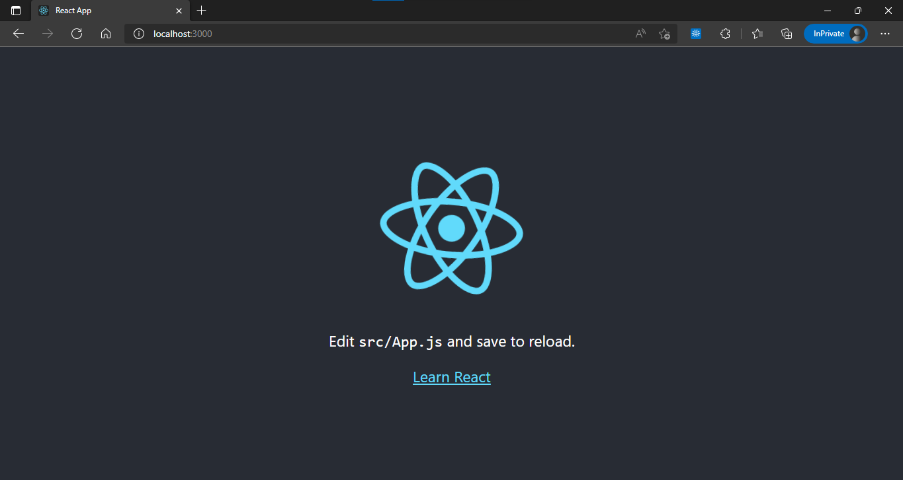

### Step 4 : Launch JSON server

Setup json server to serve the database json file on port 4000, as 3000 is in use by React

***json-server --watch .\src\user_defined\database_files\events.json --port 4000***

| events.json |
| --- |
| {  "events": [  {  "ename": "",  "evenue": "",  "edate": "",  "edescription": "",  "id":  }  ]  } |

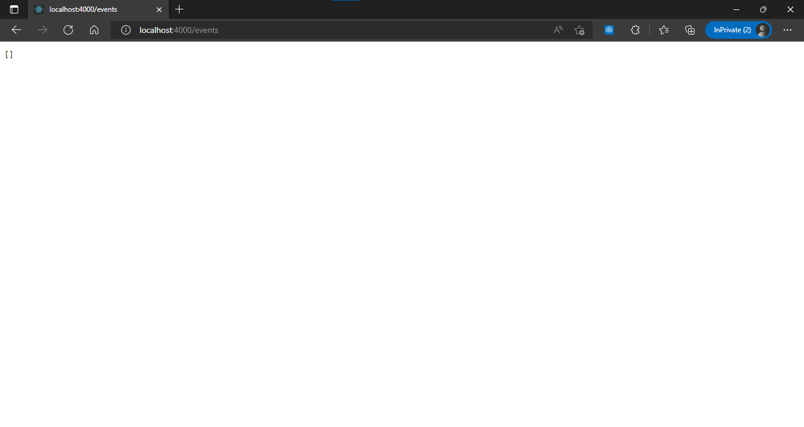

import bootstrap css & bootstrap bundle in app.js to enable bootstrap

***import "bootstrap/dist/css/bootstrap.min.css";***

***import "bootstrap/dist/js/bootstrap.bundle.min";***

Add photo as background image

| App.css |
| --- |
| …  .logoarea {  background-image: url('https://images.unsplash.com/photo-1522158637959-30385a09e0da?ixlib=rb-1.2.1&ixid=MnwxMjA3fDB8MHxwaG90by1wYWdlfHx8fGVufDB8fHx8&auto=format&fit=crop&w=870&q=80');  background-position-y: 225px;  height: 100px;  align-items: center;  color: khaki;  } |

### Step 5 : Configure Redux Store & logic for State Management

Add the store as a provider for App.js which contains the logic for all the components to display in the browser. This will enable state management in all the components referenced in App.js and all below.

| index.js |
| --- |
| import React from 'react';  import ReactDOM from 'react-dom/client';  import './index.css';  import App from './App';  import reportWebVitals from './reportWebVitals';  import { Provider } from 'react-redux';  import { store } from './event_module/redux/store';  const root = ReactDOM.createRoot(document.getElementById('root'));  root.render(  <React.StrictMode>  <Provider store={store}>  <App />  </Provider>  </React.StrictMode>  );  reportWebVitals(); |

Add the banner with the title of the App and an image background

| App.js |
| --- |
| import './App.css';  import "bootstrap/dist/css/bootstrap.min.css";  import "bootstrap/dist/js/bootstrap.bundle.min";  import PageDefault from './event_module/components/page_default';  function App() {  return (  <div className='container'>  <div className='logoarea d-flex justify-content-center'>  <h1 className='bg-secondary bg-gradient'>Wazzup Event Horizon</h1>  </div>  <PageDefault/>  </div>  );  }  export default App; |

#### Configure Event Actions

Add the API URL of the fake API (json server) to the environment variables

| .env |
| --- |
| REACT_APP_API_URL=http://localhost:4000/events |

Enter the API calls for different CRUD methods in event-services.js, which will connect the buttons in the application to the different CRUD methods like get (retrieve data), post (send data), put (update data) & delete (delete data)

| event-services.js |
| --- |
| import axios from 'axios'  // const url = 'http://localhost:4000/events';  const url = process.env.REACT_APP_API_URL;  class EventServices{  create(data) {  return axios.post(url, data.events)  }  getAll() {  return axios.get(url)  }  get(id) {  return axios.get(`${url}/${id}`)  }  update(id, data) {  return axios.put(`${url}/${id}`, data)  }  delete(id) {  console.log(`inside event services : id : ${id}`)  return axios.delete(`${url}/${id}`)  }  findByDate(date) {  return axios.get(`${url}/?edate=${date}`)  }  findByVenue(venue) {  return axios.get(`${url}/?evenue=${venue}`)  }  }  export default new EventServices(); |

Enter the different event action types for the reducer function. Also add the mapToProps constant which will update the state of the component for each method call in each component

| event_types.js |
| --- |
| export const CREATE_EVENT = "CREATE_EVENT";  export const RETRIEVE_EVENTS = "RETRIEVE_EVENTS";  export const UPDATE_EVENT = "UPDATE_EVENT";  export const DELETE_EVENT = "DELETE_EVENT";  export const SELECT_DATATYPE = "SELECT_DATATYPE";  export const mapStateToProps = (state) => {  return {  data : state.payload  }  } |

Add the event methods with data types and payloads for the reducer function. Whatever option is matched in the switch function of the reducer to the event types will return the respective payload

| event_methods.js |
| --- |
| import { CREATE_EVENT, DELETE_EVENT, RETRIEVE_EVENTS, SELECT_DATATYPE, UPDATE_EVENT } from "./event_types"  export const createAnEvent = (data) => {  return {  type : CREATE_EVENT,  payload : data  }  }  export const getAllEvents = (data) => {  return {  type : RETRIEVE_EVENTS,  payload : data  }  }  export const getEventById = (data) => {  return {  type : RETRIEVE_EVENTS,  payload : data  }  }  export const updateEventById = (data) => {  return {  type : UPDATE_EVENT,  payload : data  }  }  export const deleteEventById = (id) => {  console.log(`inside event methods : id ${id}`)  return {  type : DELETE_EVENT,  payload : id  }  }  export const getEventByDate = (data) => {  return {  type : RETRIEVE_EVENTS,  payload : data  }  }  export const getEventByVenue = (data) => {  return {  type : RETRIEVE_EVENTS,  payload : data  }  }  export const getSelectedDataType = (data) => {  return {  type : SELECT_DATATYPE,  payload : data  }  } |

The event actions will map the data type and payload to the axios API methods mentioned in event_services.js and dispatch it to the store, where the state is updated and retrieved in the components accordingly

| event_actions.js |
| --- |
| import EventServices from "../../services/event-services"  import { createAnEvent, deleteEventById, getAllEvents, getEventByDate, getEventById, getEventByVenue, getSelectedDataType, updateEventById } from "./event_methods";  export const createEvent = (events) => {  return (dispatch) =>{  return EventServices.create({events})  .then(response => {  dispatch(createAnEvent(response.data))  })  .catch(err=>{throw(err)})  }  }  export const retrieveEvents = () => {  return (dispatch) => {  return EventServices.getAll()  .then(response => {  console.log("in event actions, get all", response.data)  dispatch(getAllEvents(response.data))  })  .catch(err => {throw(err)})  }  }  export const findEventByID = (id) => {  return (dispatch) => {  return EventServices.get(id)  .then(response => {  dispatch(getEventById(response.data))  })  .catch(err => {throw(err)})  }  }  export const updateEvent = (id, data) => {  return (dispatch) => {  return EventServices.update(id, data)  .then(response => {  dispatch(updateEventById(response.data))  })  .catch(err => {throw(err)})  }  }  export const deleteEvent = (id) => {  console.log(`inside event actions : delete : id : ${id}`)  return (dispatch) => {  return EventServices.delete(id)  .then(response => {  console.log(`inside event actions : response.data : ${response.data}`)  dispatch(deleteEventById(response.data))  })  .catch(err => {throw(err)})  }  }  export const findEventByDate = (date) => {  return (dispatch) => {  return EventServices.findByDate(date)  .then(response => {  dispatch(getEventByDate(response.data))  })  .catch(err => {throw(err)})  }  }  export const findEventByVenue = (venue) => {  return (dispatch) => {  return EventServices.findByVenue(venue)  .then(response => {  dispatch(getEventByVenue(response.data))  })  .catch(err => {throw(err)})  }  }  export const selectDataTypes = (info) =>{  return (dispatch) => {  dispatch(getSelectedDataType(info))  }  } |

#### Configure Event Reducers

Create a reducer function which sets the initial state as an empty array (multiple values) and uses a switch function to match event types to event_actions.js & event_methods.js to return the state (if required) and the respective data payload

| event_reducer.js |
| --- |
| import { CREATE_EVENT, DELETE_EVENT, RETRIEVE_EVENTS, SELECT_DATATYPE, UPDATE_EVENT } from "../actions/event_types";  export default function EventReducer(state=[], action){  switch(action.type){  case CREATE_EVENT:  return [...state, action.payload]  case RETRIEVE_EVENTS:  return action.payload  case UPDATE_EVENT:  if(state.id === action.payload.id){  return {...state, ...action.payload}  }else{  return state  }  case DELETE_EVENT:  console.log("in event reducer delete events:",action.payload)  return action.payload  case SELECT_DATATYPE:  return action.payload  default:  return state  }  } |

If there are multiple reducer functions for different tasks, like authorization/login then combine_reducer combines all the reducer functions into a single reducer function which can be used to create the store

| combine_reducer.js |
| --- |
| import { combineReducers } from "redux";  import payload from './event_reducer';  export default combineReducers({  payload : payload  }); |

#### Configure Redux Store

create the store with thunk middleware using the combine reducer

| store.js |
| --- |
| import { applyMiddleware, createStore } from "redux";  import thunk from "redux-thunk";  import { retrieveEvents } from "./actions/event_actions";  import combineReducers from "./reducers/combine_reducer";  export const store = createStore(combineReducers, applyMiddleware(thunk));  store.dispatch(retrieveEvents())  store.subscribe(()=>console.log("in store state:", store.getState())); |

### Step 6 : Configure Components (view logic)

page_default.js contains the business logic to display the navbar

| page_default.js |
| --- |
| import React from 'react'  import Navbar from './navbar'    export default function PageDefault() {  return (  <div className="row align-self-center">  <div className="col"/>  <div className="col-8 text-white">  <Navbar/>  </div>  <div className="col"/>  </div>  )  } |

#### Navbar

Logic to display the navbar with the selected component information

| navbar.js |
| --- |
| import React from 'react'  import { BrowserRouter, Link, Route, Routes } from 'react-router-dom'  import AddEvent from './add_event'  import Credits from './credits'  import SearchEvent from './search_event'  import ShowEvents from './show_events'  import UpdateEvent from './update_event'  export default function Navbar() {  return (  <BrowserRouter>  <nav className="row">  <div className="col"/>  <div className="col-8">  <div className="nav nav-tabs" role="tablist">  <button className="nav-link bg-dark" data-bs-toggle="tab">  <Link to={'/show'}>Show Events</Link>  </button>  <button className="nav-link bg-dark" data-bs-toggle="tab">  <Link to={'/search'}>Search Event</Link>  </button>  <button className="nav-link bg-dark" data-bs-toggle="tab">  <Link to={'/add'}>Create Event</Link>  </button>  <button className="nav-link bg-dark" data-bs-toggle="tab">  <Link to={'/credits'}>Credits</Link>  </button>  </div>  </div>  <div className="col"/>  </nav>    <Routes>  <Route exact path="/show" element={<ShowEvents/>}/>  <Route exact path="/search" element={<SearchEvent/>}/>  <Route exact path="/add" element={<AddEvent/>}/>  <Route exact path="/credits" element={<Credits/>}/>  <Route path="/update/:id" element={<UpdateEvent/>}/>  </Routes>  </BrowserRouter>  )  } |

#### CREATE

use forms to send the data to the API server with connect to connect to the redux store and bootstrap classes for RWD. The function createEvent along with other functions to be executed during runtime can be attached as onClick button events, which have to be bound to the functions to reflect changes without reverting.

| add_event.js |
| --- |
| import React, { Component } from 'react'  import { connect } from 'react-redux'  import { createEvent } from '../redux/actions/event_actions'  class AddEvent extends Component {  constructor(props) {  super(props)    this.ename = React.createRef();  this.evenue = React.createRef();  this.edate = React.createRef();  this.edescription = React.createRef();  this.state = {}  this.saveEvent = this.saveEvent.bind(this);  }  saveEvent(){  let events = {  ename : this.ename.current.value,  evenue : this.evenue.current.value,  edate : this.edate.current.value,  edescription : this.edescription.current.value  }    this.props.createEvent(events)  }  render() {  return (  <div>  <h3 className="text-center bg-secondary">Create an Event</h3>  <hr/>  <div className="card center">  <div className="card-body bg-dark">  <div className="row">  <div className="col">  <label className="col-form-label">Name</label>  </div>  <div className="col-9">  <input type="text" className="form-control mb-2" ref={this.ename}/>  </div>  </div>  <div className="row">  <div className="col">  <label className="col-form-label">Venue</label>  </div>  <div className="col-9">  <input type="text" className="form-control mb-2" ref={this.evenue}/>  </div>  </div>  <div className="row">  <div className="col">  <label className="col-form-label">Date</label>  </div>  <div className="col-9">  <input type="date" className="form-control mb-2" ref={this.edate}/>  </div>  </div>  <div className="row">  <div className="col">  <label className="col-form-label">Description</label>  </div>  <div className="col-9">  <textarea className="form-control mb-2" ref={this.edescription}/>  </div>  </div>  <div className="row">  <div className="col"/>  <button className="btn btn-success col-5" onClick={this.saveEvent}>Submit</button>  <div className="col"/>  </div>  </div>  </div>  </div>  )  }  }  export default connect(null, {createEvent})(AddEvent); |

#### READ

the data to be read or retrieved and displayed in browser is in the form of an array, hence using index and pagination with a list mapping will allow displaying the data in a neat and arranged manner (aesthetically pleasing).

| show_events.js |
| --- |
| import React, { useState } from 'react';  import { connect } from "react-redux";  import { retrieveEvents } from '../redux/actions/event_actions';  import { mapStateToProps } from '../redux/actions/event_types'  function ShowEvents({data}) {  const [currentIndex, setCurrentIndex] = useState(0)    const previousPage = (currentIndex) => {  if(currentIndex>0){  console.log("previous", currentIndex)  return setCurrentIndex(currentIndex - 5)  }  }    const nextPage = (currentIndex) => {  if(currentIndex<=data.length/5){  console.log("next", currentIndex)  return setCurrentIndex(currentIndex + 5)  }  }  let response  !data ?  response = <p><strong>No Data Found</strong></p> :  response =  (  <div>  {  data.slice(currentIndex,currentIndex+5).map((x) =>  <div className="card center" key={x.id}>  <div className="card-body bg-dark">  <h5 className="card-title">{x.ename}</h5>  <p className="card-text">  Venue: {x.evenue} | Date: {x.edate}  <br/>  {x.edescription}  </p>  </div>  </div>  )  }  </div>  )  let pagination =  (  <nav>  <ul className="pagination">  <li className="page-item">  <button className="page-link" onClick={()=>previousPage(currentIndex)}>Previous</button>  </li>  <li className="page-item">  <p className="page-link">Page {Math.ceil(currentIndex/5)+1} of {Math.ceil(data.length/5)}</p>  </li>  <li className="page-item">  <button className="page-link" onClick={()=>nextPage(currentIndex)}>Next</button>  </li>  </ul>  </nav>  )  return (  <div>  <h3 className="text-center bg-secondary">List of Events</h3>  <hr/>  {response}  <hr/>  <div className="row">  <div className="col"/>  <div className="col-5">  {pagination}  </div>  <div className="col"/>  </div>  </div>  )  }  export default connect(mapStateToProps, { retrieveEvents })(ShowEvents) |

#### Find/Search

Create the logic to search by ID, date & venue, depending on the option chosen by utilizing dropdown. The data retrieved will be an object in case of ID & array (single or multiple lines) in case of venue or date. If statement can be used to match the data to the presentation format. For each record displayed, there is an update and delete button.

| search_event.js |
| --- |
| import React, { Component } from 'react'  import { connect } from 'react-redux'  import { Link } from 'react-router-dom'  import { findEventByID, findEventByDate, findEventByVenue, selectDataTypes, deleteEvent } from '../redux/actions/event_actions'  import { mapStateToProps } from '../redux/actions/event_types'  import { store } from '../redux/store'  class SearchEvent extends Component {  constructor(props) {  super(props)    this.eoptions = React.createRef();  this.datatype = React.createRef();  this.state = {}    this.handleDropdownOptions = this.handleDropdownOptions.bind(this);  this.startSearch = this.startSearch.bind(this);  this.showResults = this.showResults.bind(this);  this.getIdData = this.getIdData.bind(this);  this.deleteData = this.deleteData.bind(this);  }  handleDropdownOptions(event){  this.props.selectDataTypes(event.target.value)  }  startSearch(){  switch(store.getState().payload){  case "id":  this.props.findEventByID(this.eoptions.current.value)  break  case "date":  this.props.findEventByDate(this.eoptions.current.value)  break  case "venue":  this.props.findEventByVenue(this.eoptions.current.value)  break  default:  alert("search field not found")  }  }  getIdData(e){  this.props.findEventByID(e)  }  deleteData(e){  console.log(`in search event : delete data id : ${e}`)  this.props.deleteEvent(e)  }  showResults(){  let data = store.getState().payload  let response  if(!data){  response = <p><strong>No Data Found</strong></p>  }else if(Array.isArray(data)===false){  response =  (  <div className="card center">  <div className="card-body bg-dark">  <h5 className="card-title">{data.ename}</h5>  <p className="card-text">  Venue: {data.evenue} | Date: {data.edate}  <br/>  {data.edescription}  </p>  <button className="btn btn-success mx-1" onClick={()=>this.getIdData(data.id)}><Link className="text-decoration-none text-white" to={`/update/${data.id}`}>Update</Link></button>  <button className="btn btn-danger mx-1" onClick={()=>this.deleteData(data.id)}>Delete</button>  </div>  </div>  )  }else if(Array.isArray(data)===true){  response =  (  <div>  {  data.map((x) =>  <div className="card center" key={x.id}>  <div className="card-body bg-dark">  <h5 className="card-title">{x.ename}</h5>  <p className="card-text">  Venue: {x.evenue} | Date: {x.edate}  <br/>  {x.edescription}  </p>  <button className="btn btn-success mx-1" onClick={()=>this.getIdData(x.id)}><Link className="text-decoration-none text-white" to={`/update/${x.id}`}>Update</Link></button>  <button className="btn btn-danger mx-1" onClick={()=>this.deleteData(x.id)}>Delete</button>  </div>  </div>  )  }  </div>  )  }  this.setState({response : response})  }  render(){  let type  if (Array.isArray(store.getState().payload)===false)  type = store.getState().payload  return (  <div>  <h3 className="text-center bg-secondary">Search Events</h3>    <div className="container bg-dark py-2">  <div className="row">  <div className="col">  <select className="h-100 d-inline-block mx-1 btn btn-primary" onChange={this.handleDropdownOptions} value={this.datatype} ref={this.datatype}>  <option value="">---select---</option>  <option value="id">Search By ID</option>  <option value="date">Search By Date</option>  <option value="venue">Search By Venue</option>  </select>  </div>  <div className="col-4">  <input className="h-100 d-inline-block mx-1 form-control" type={type} placeholder={`Enter ${type} to search`} ref={this.eoptions} style={{height:"40px"}}/>  </div>  <div className="col-2">  <button className="btn btn-primary h-100 d-inline-block mx-1" onClick={this.startSearch}>Search</button>  </div>  <div className="col">  <button className="btn btn-info h-100 d-inline-block mx-1" onClick={this.showResults}>Show Results</button>  </div>  </div>  </div>  <hr/>  {this.state.response}  </div>  )  }  }  export default connect(mapStateToProps, { findEventByID, findEventByDate, findEventByVenue, selectDataTypes, deleteEvent })(SearchEvent) |

#### UPDATE

if the update button is clicked, then the logic redirects the user to the update page, where the data in the current record is shown in a fixed box, with blank fields for the data to be updated.

| update_event.js |
| --- |
| import React, { Component } from 'react'  import { connect } from 'react-redux'  import { updateEvent } from '../redux/actions/event_actions'  import { mapStateToProps } from '../redux/actions/event_types'  import { store } from '../redux/store'  class UpdateEvent extends Component {  constructor(props) {  super(props)    this.ename = React.createRef();  this.evenue = React.createRef();  this.edate = React.createRef();  this.edescription = React.createRef();  this.state = {}  this.updateEvent = this.updateEvent.bind(this)  }  updateEvent(){  let id = store.getState().payload.id  let event = {  ename : this.ename.current.value,  evenue : this.evenue.current.value,  edate : this.edate.current.value,  edescription : this.edescription.current.value  }  this.props.updateEvent(id, event)  }  render() {  let data = store.getState().payload  return (  <div>  <h3 className="text-center bg-secondary">Update an Event</h3>  <hr/>  <div className="card center">  <div className="card-body bg-dark">  <div className="row">  <div className="col"/>  <div className="col-5">  <label className="col-form-label">Current</label>  </div>  <div className="col-5">  <label className="col-form-label">Updated</label>  </div>  </div>  <div className="row">  <div className="col">  <label className="col-form-label">Name</label>  </div>  <div className="col-5">  <input className="form-control mb-2" value={data.ename} readOnly={true}/>  </div>  <div className="col-5">  <input className="form-control mb-2" type="text" ref={this.ename} required placeholder="Enter name to update"/>  </div>  </div>  <div className="row">  <div className="col">  <label className="col-form-label">Venue</label>  </div>  <div className="col-5">  <input className="form-control mb-2" value={data.evenue} readOnly={true}/>  </div>  <div className="col-5">  <input className="form-control mb-2" type="text" ref={this.evenue} required placeholder="Enter venue to update"/>  </div>  </div>  <div className="row">  <div className="col">  <label className="col-form-label">Date</label>  </div>  <div className="col-5">  <input className="form-control mb-2" value={data.edate} readOnly={true}/>  </div>  <div className="col-5">  <input className="form-control mb-2" type="date" ref={this.edate} required/>  </div>  </div>  <div className="row">  <div className="col">  <label className="col-form-label">Description</label>  </div>  <div className="col-5">  <textarea className="form-control mb-2" value={data.edescription} readOnly={true}/>  </div>  <div className="col-5">  <textarea className="form-control mb-2" ref={this.edescription} required placeholder="Enter description to update"/>  </div>  </div>  <div className="row justify-content-center">  <button className="btn btn-success col-5" onClick={this.updateEvent}>Submit</button>  </div>  </div>  </div>  </div>  )  }  }  export default connect(mapStateToProps, {updateEvent})(UpdateEvent); |

#### DELETE

The delete logic is contained in search_event.js, when the delete button is clicked, the respective function is called in event_methods.js.

#### Credits

Details of references used for pictures referenced in website

| credits.js |
| --- |
| import React from 'react'  export default function Credits() {    return (  <div>  <h3 className="text-center bg-secondary">Credits</h3>  <hr/>  <div className="card bg-dark">  <div className="row">  <div className="col"/>  <div className="col-6 text-center">  <div className="card-title">Red Theatre Curtain Photo</div>  <div className="card-text">  <img src="https://images.unsplash.com/photo-1514306191717-452ec28c7814?ixlib=rb-1.2.1&ixid=MnwxMjA3fDB8MHxwaG90by1wYWdlfHx8fGVufDB8fHx8&auto=format&fit=crop&w=1469&q=80" style={{height: "100px", width: "100px"}} alt="Photo by Rob Laughter on Unsplash"/>  <p>Photo by Rob Laughter on Unsplash</p>  <a href="https://unsplash.com/photos/WW1jsInXgwM?utm_source=unsplash&utm_medium=referral&utm_content=creditShareLink">Click Here to Visit</a>  </div>  <hr/>  <div className="card-title">Group of People Watching Concert Photo</div>  <div className="card-text">  <img src="https://images.unsplash.com/photo-1522158637959-30385a09e0da?ixlib=rb-1.2.1&ixid=MnwxMjA3fDB8MHxwaG90by1wYWdlfHx8fGVufDB8fHx8&auto=format&fit=crop&w=870&q=80" style={{height: "100px", width: "100px"}} alt="Photo by Rob Laughter on Unsplash"/>  <p>Photo by Rachel Coyne on Unsplash</p>  <a href="https://unsplash.com/photos/U7HLzMO4SIY?utm_source=unsplash&utm_medium=referral&utm_content=creditShareLink">Click Here to Visit</a>  </div>  </div>  <div className="col"/>  </div>  </div>  </div>  )  } |

### Step 7 : Screenshots

Screenshots of the various actions in browser displayed below

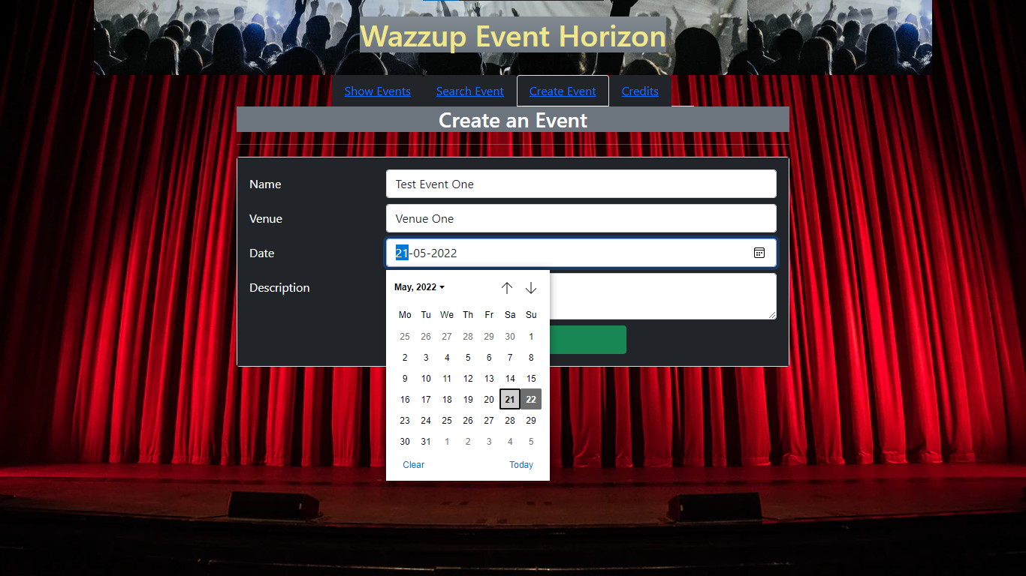

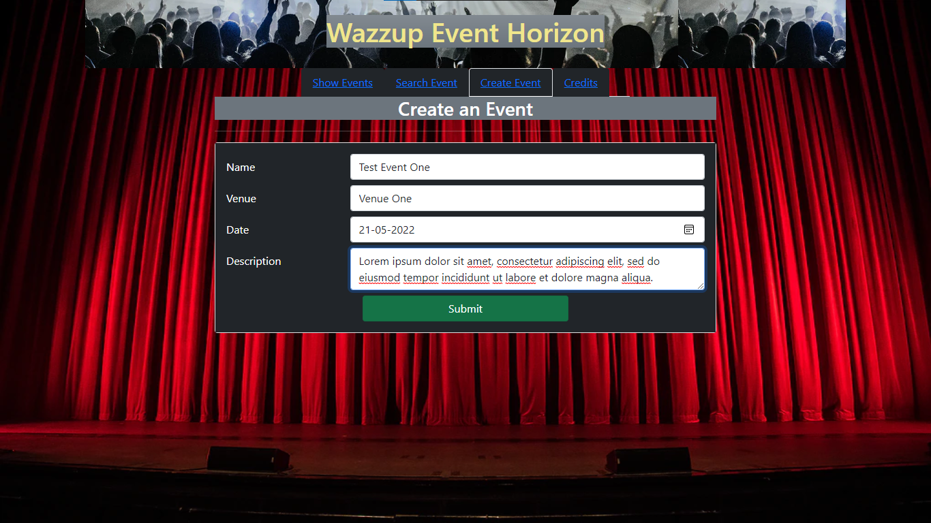

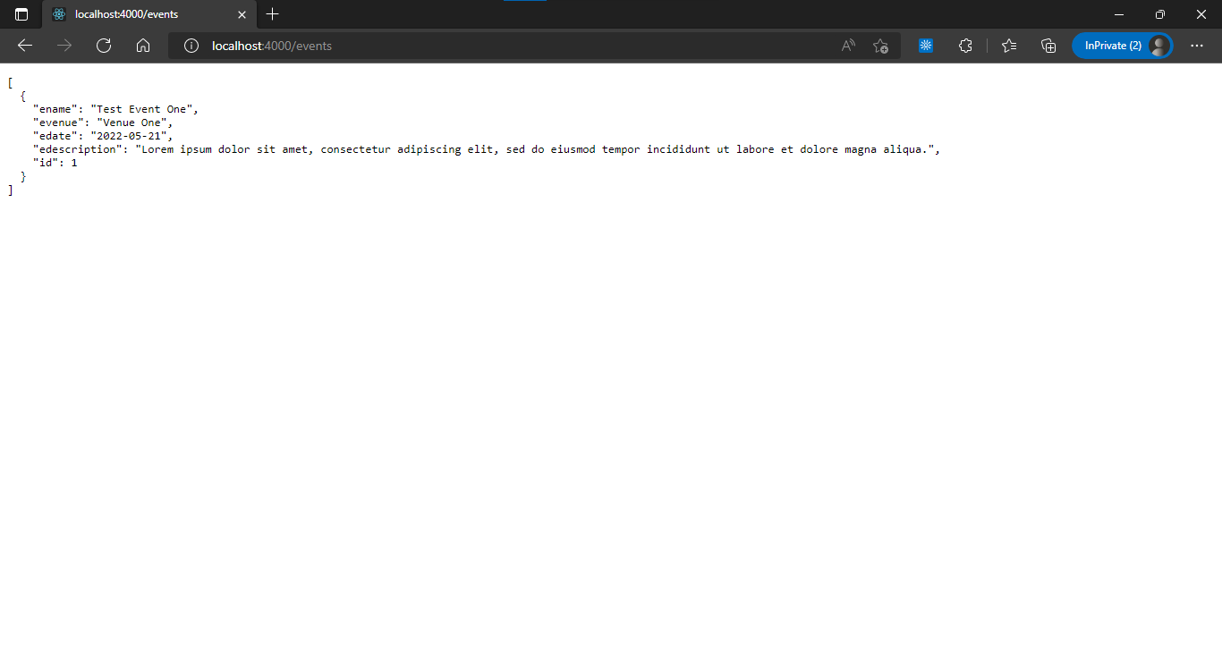

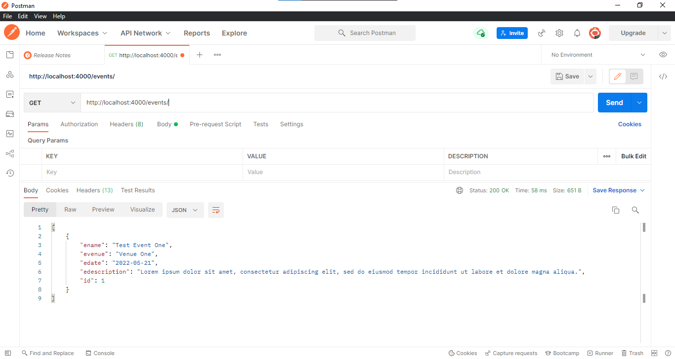

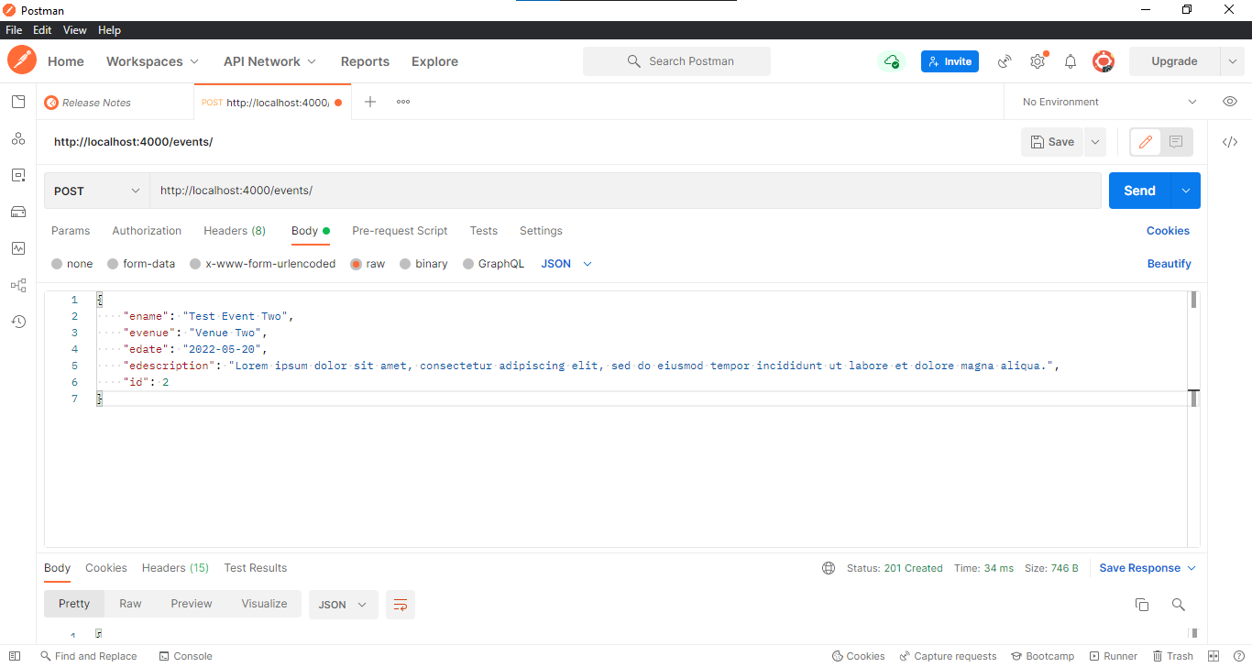

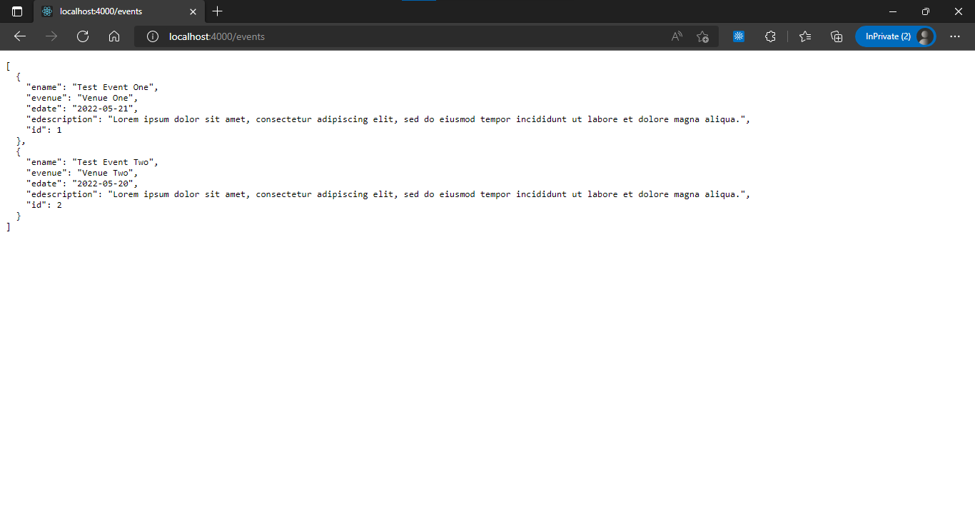

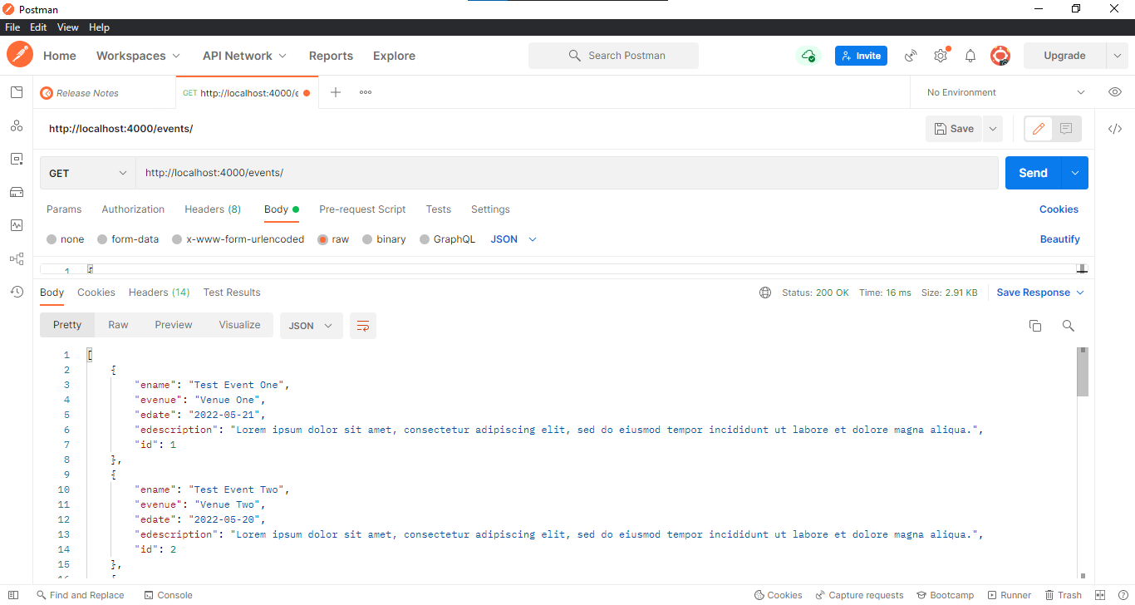

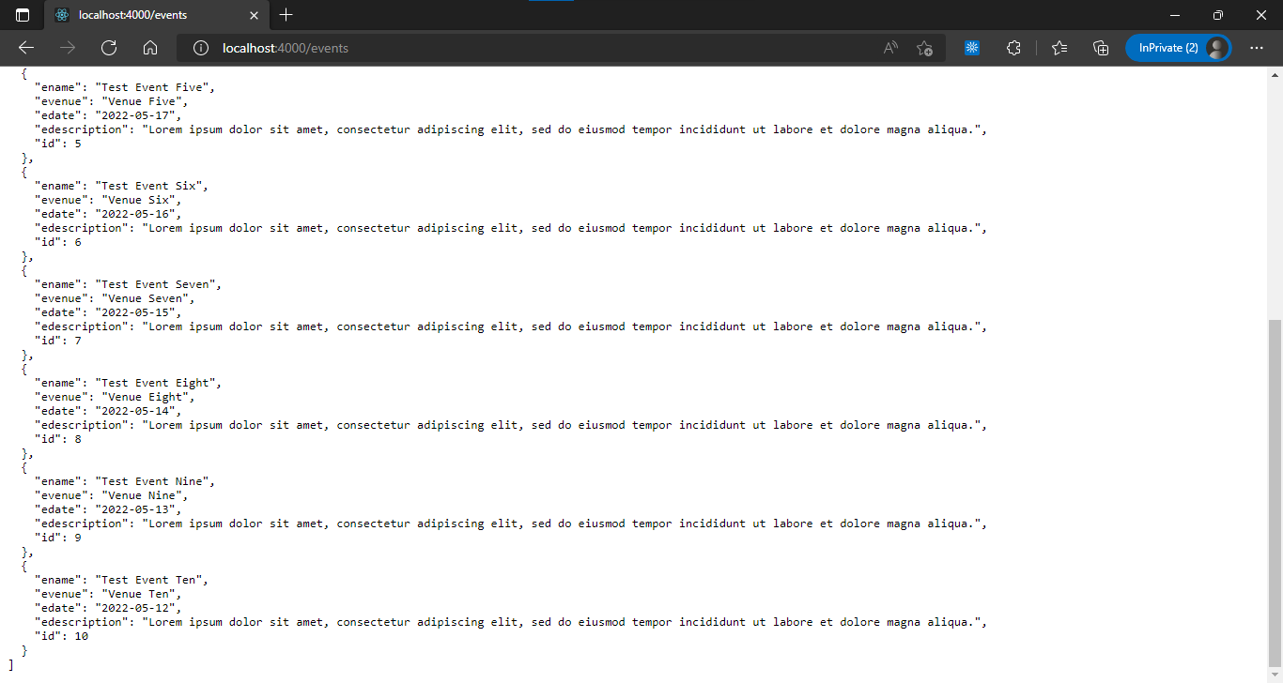

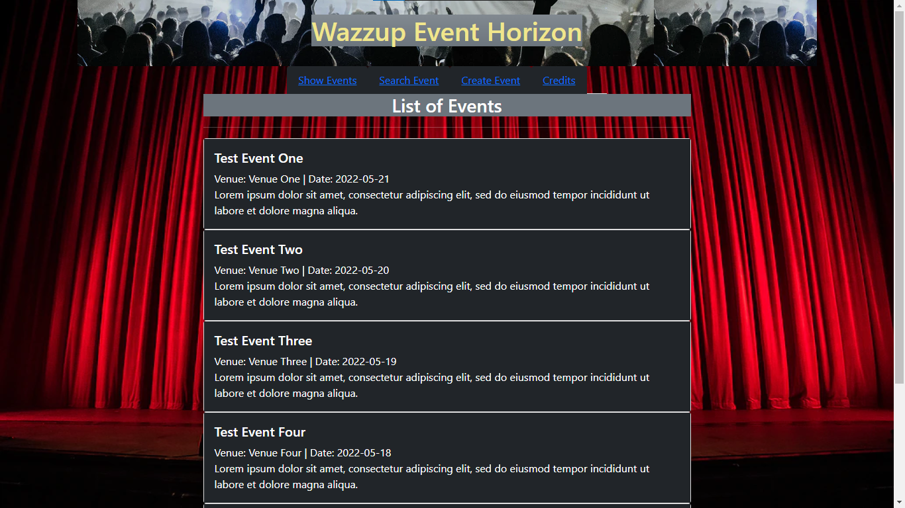

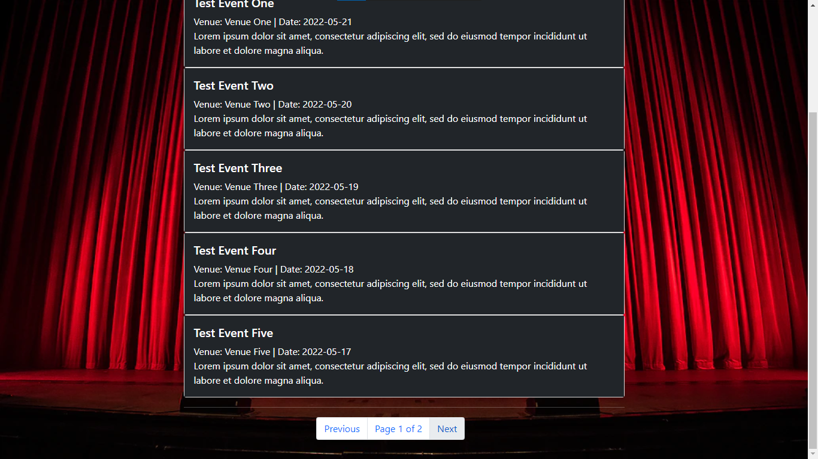

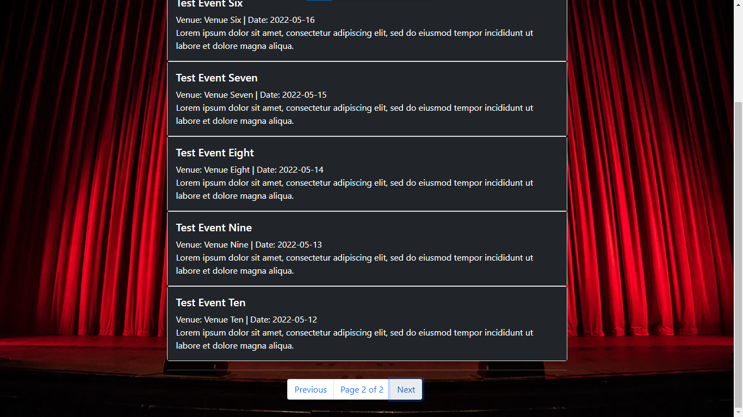

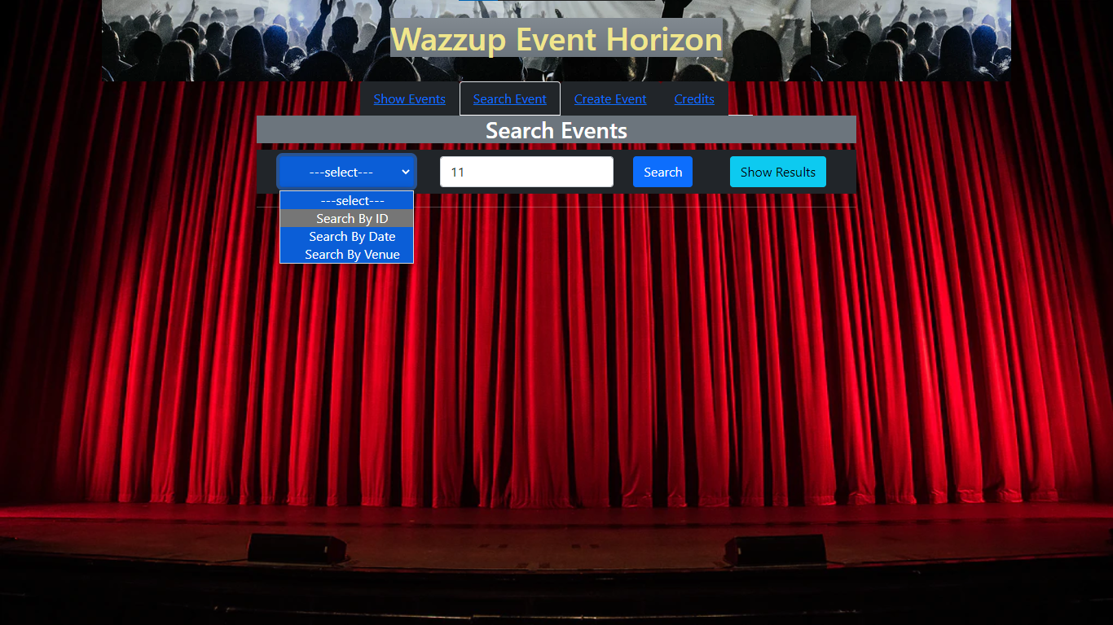

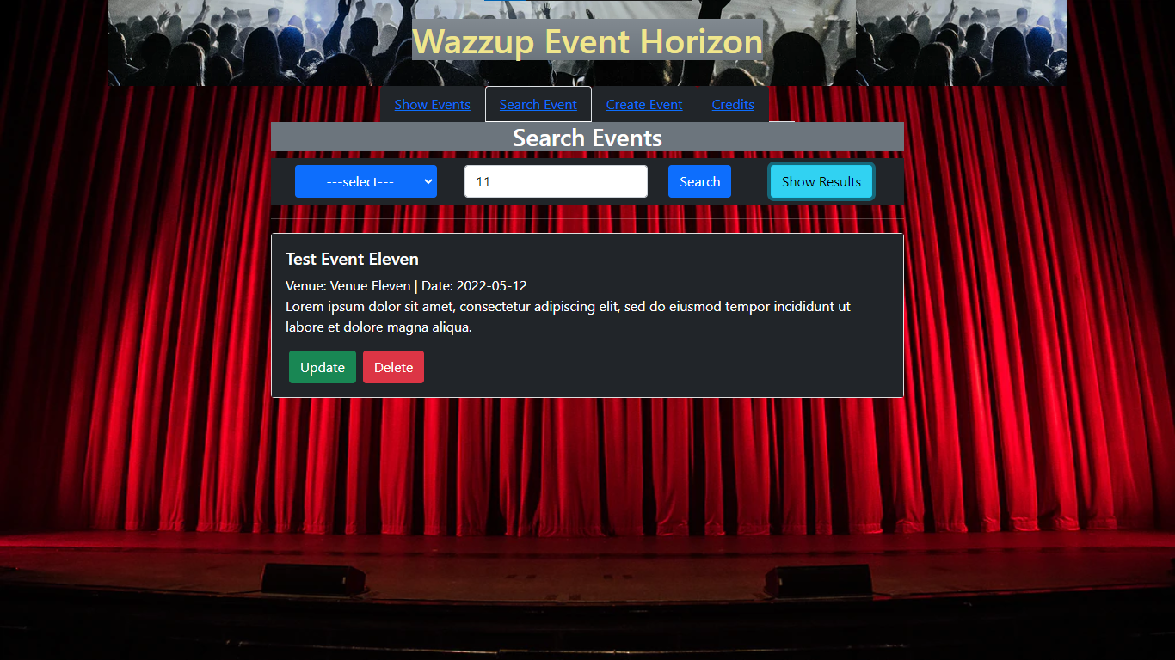

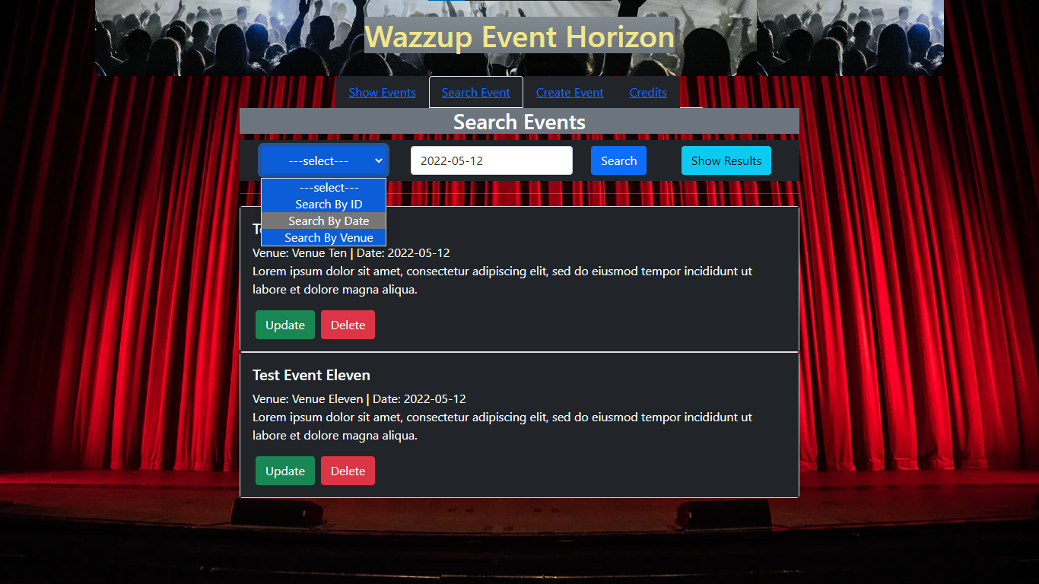

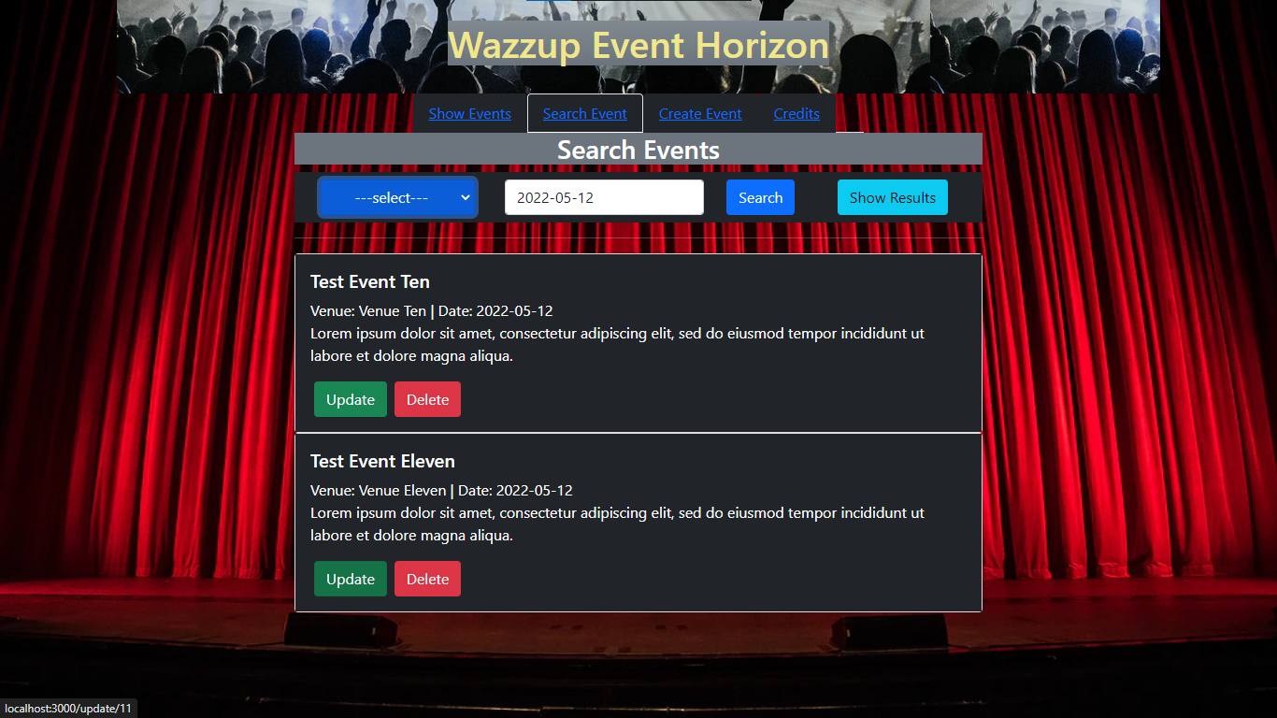

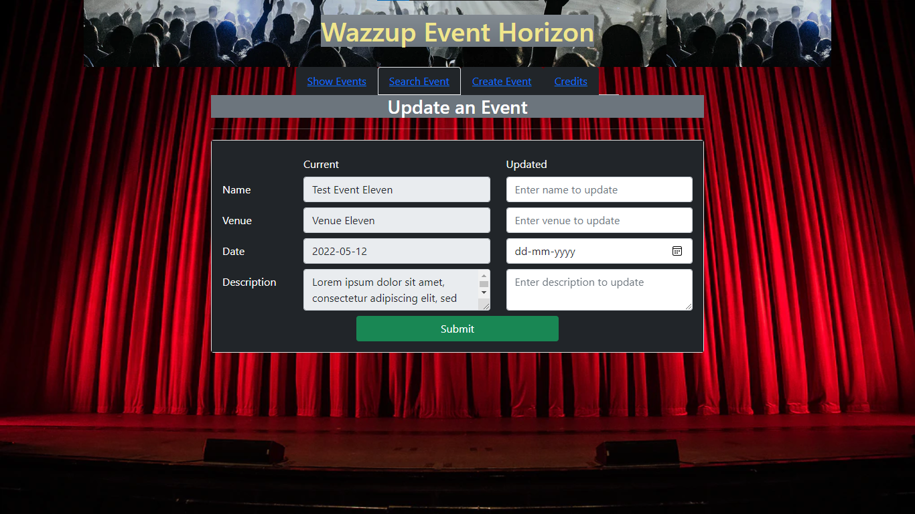

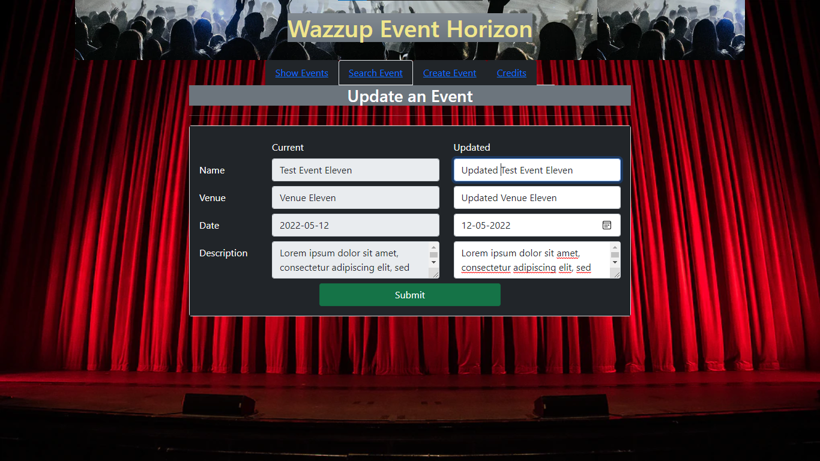

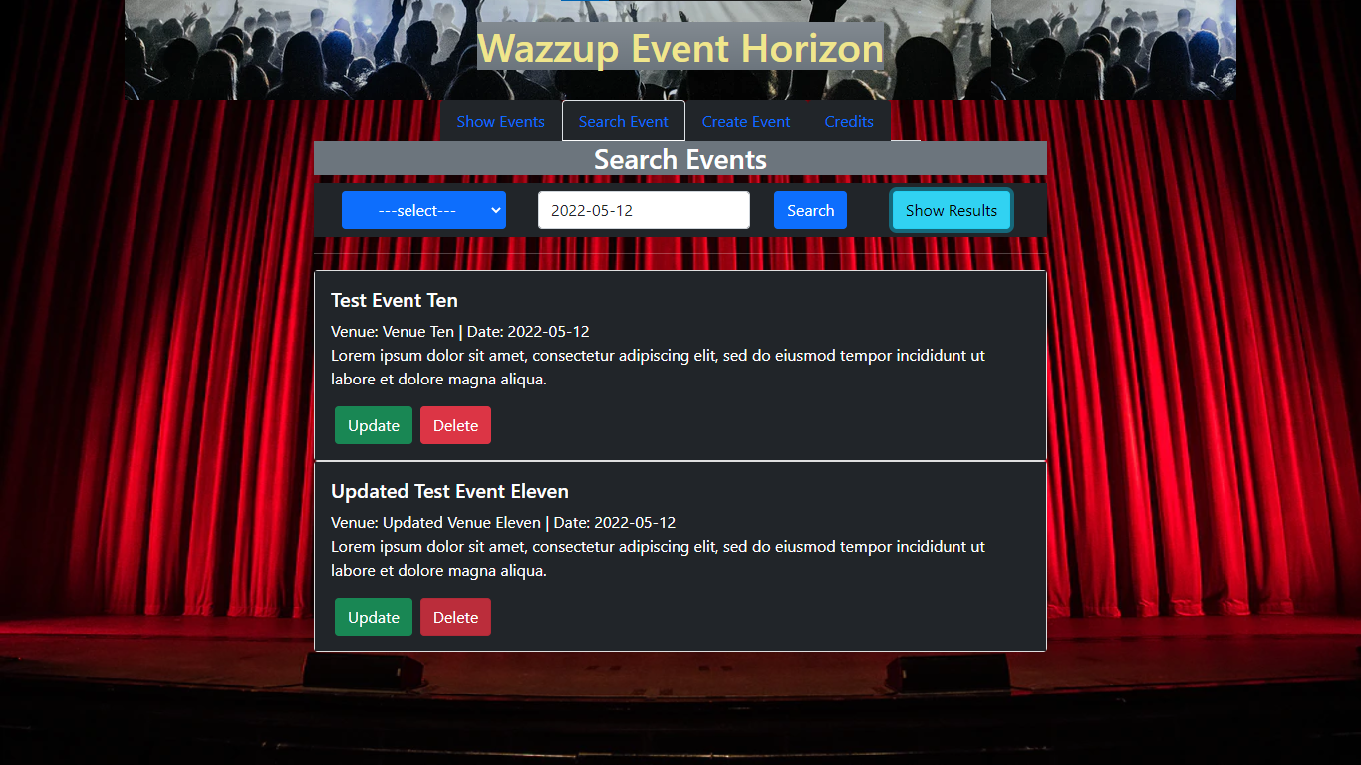

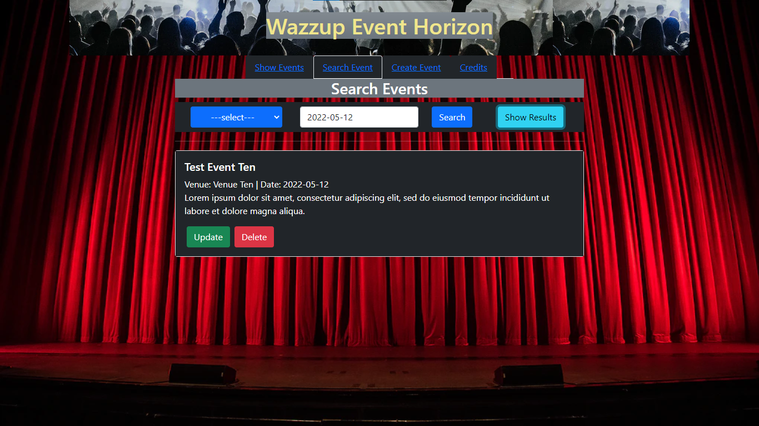

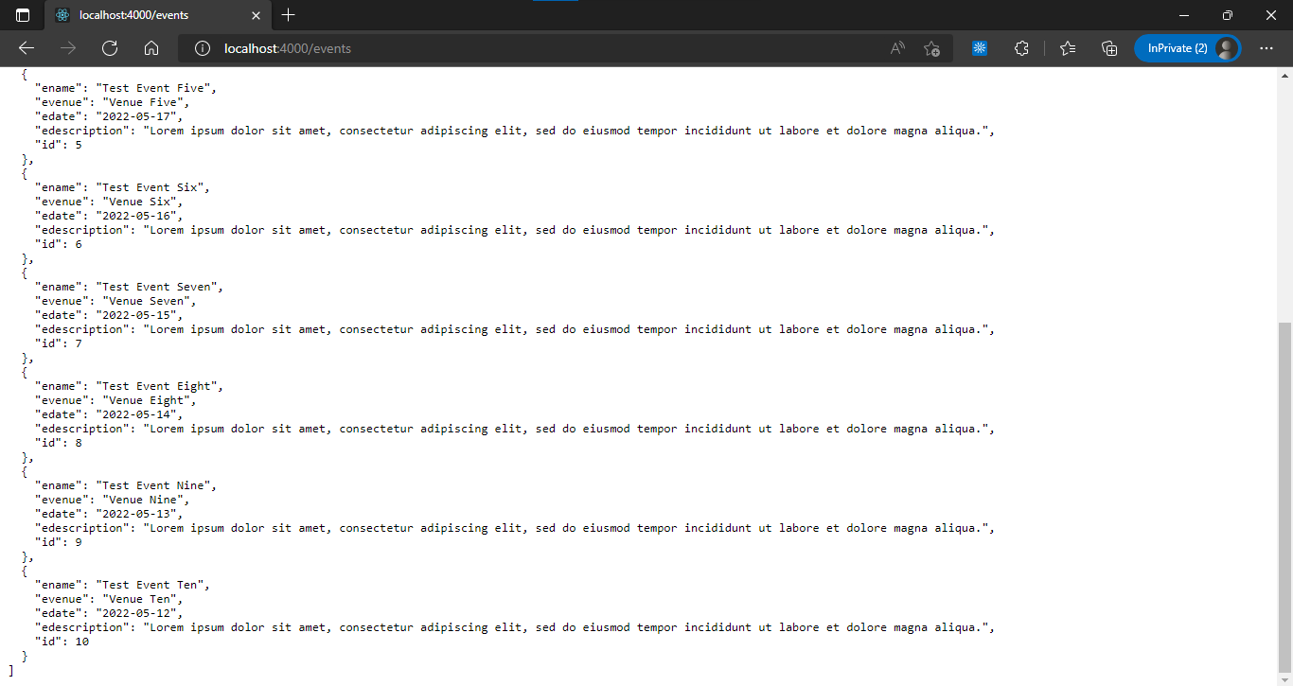

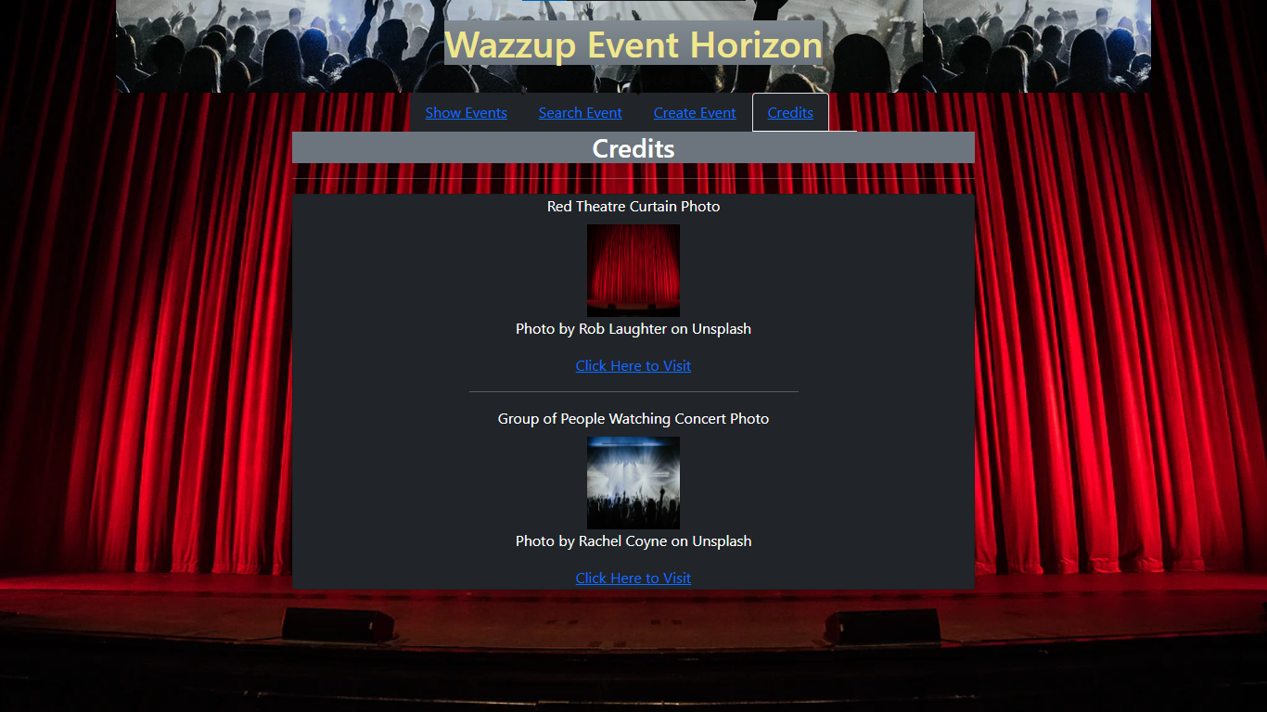

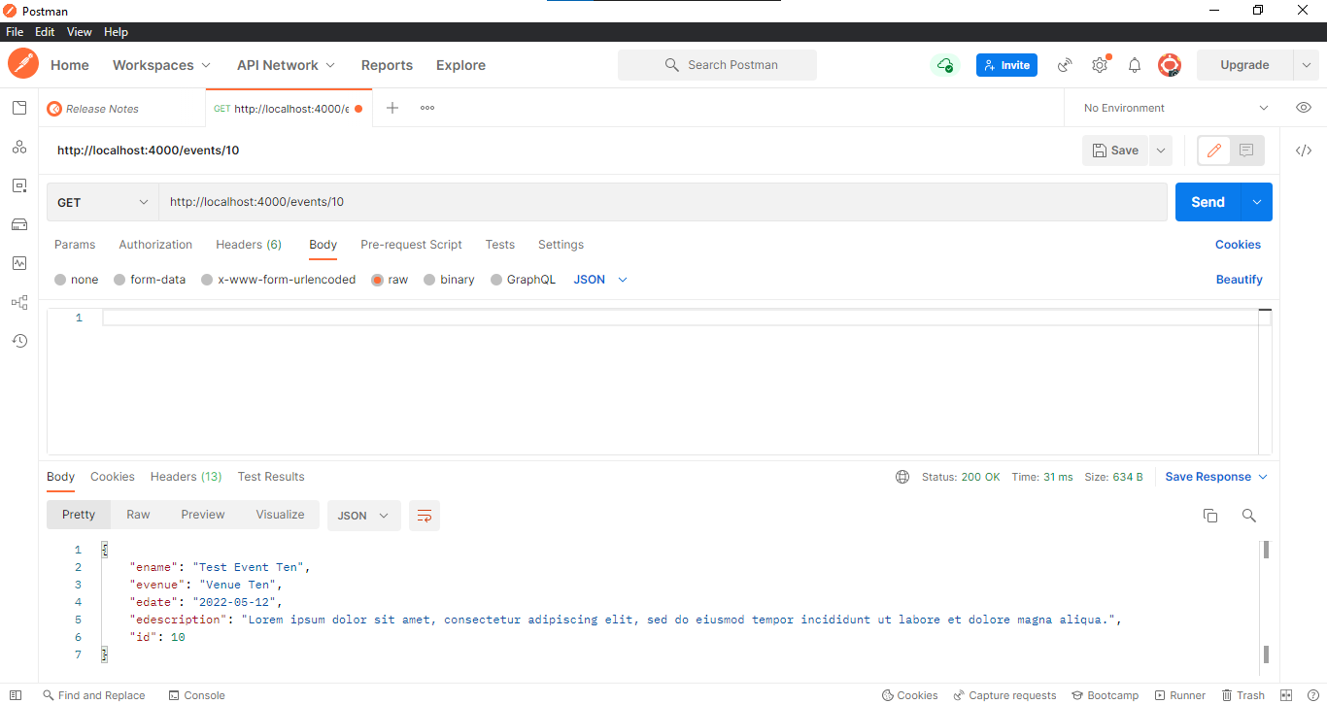

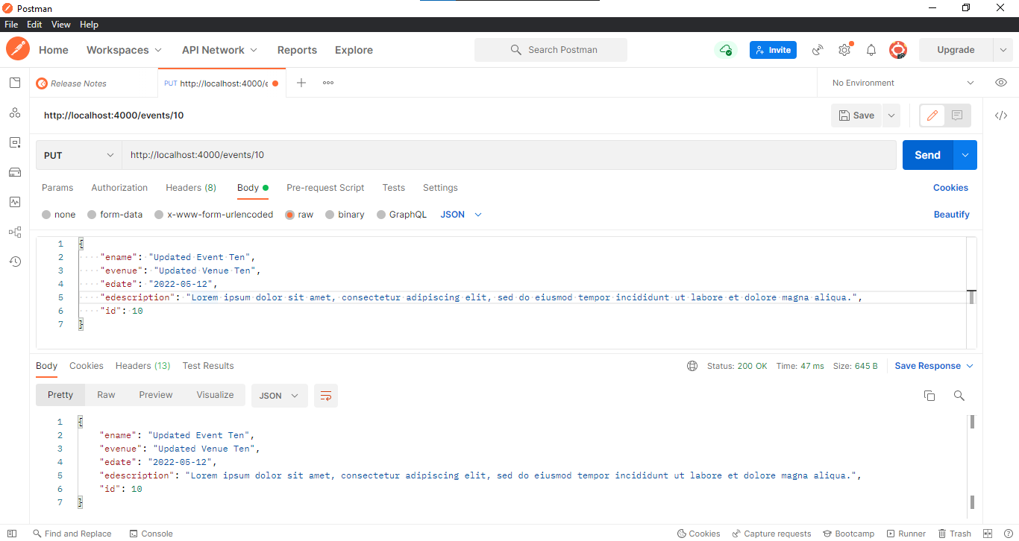

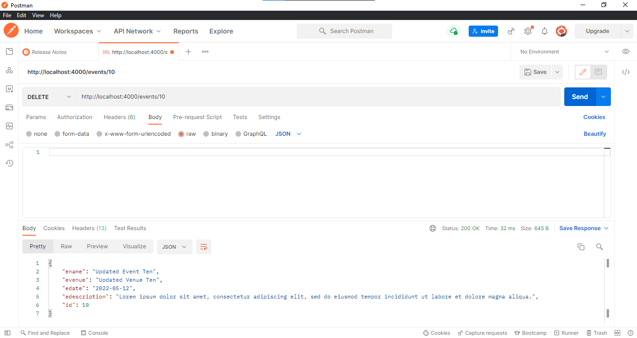

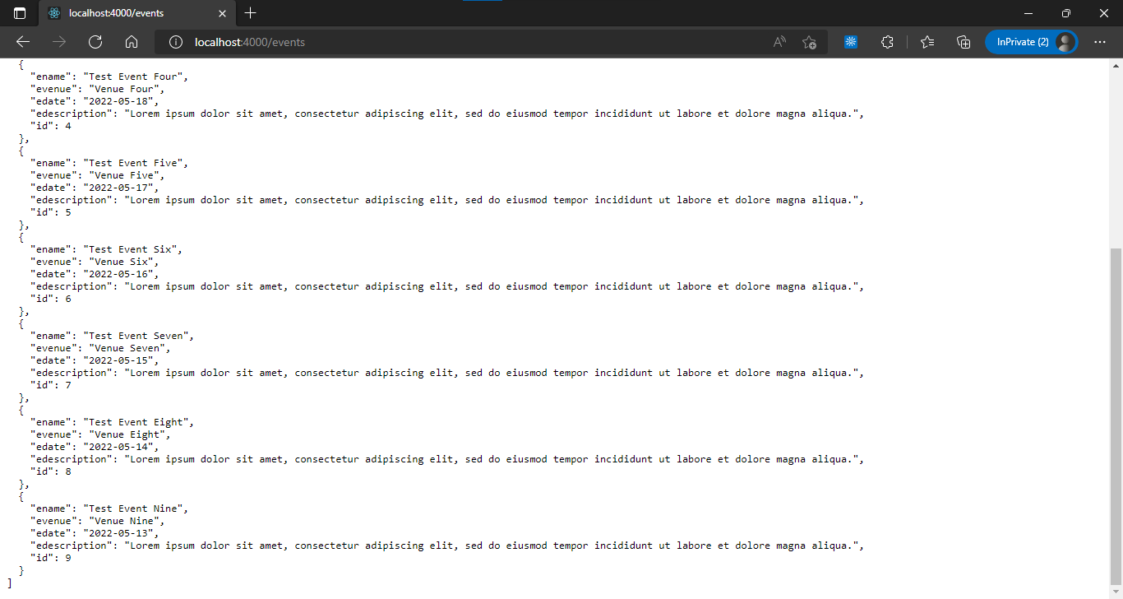

# X — — — END OF PROJECT — — — X